

**CS-114 - Fundamental of Programing**

**Lab Manual # 3**

**Home Task**

Submitted To: Engr Muhammad Affan

Submitted By: Shahzaib Murtaza (466034)

Section: B

**1. Write a program in C++ to find LCM of any two numbers using HCF.**

#include<iostream>

using namespace std;

// Function to calculate HCF of two numbers

int hcf(int a, int b) {

if (b == 0)

return a;

return hcf(b, a % b);

}

// Function to calculate LCM of two numbers

int lcm(int a, int b) {

return (a * b) / hcf(a, b);

}

int main() {

int num1, num2;

cout << "Enter first number: ";

cin >> num1;

cout << "Enter second number: ";

cin >> num2;

cout << "HCF of " << num1 << " and " << num2 << " is: " << hcf(num1, num2) << endl;

cout << "LCM of " << num1 << " and " << num2 << " is: " << lcm(num1, num2) << endl;

return 0;

}

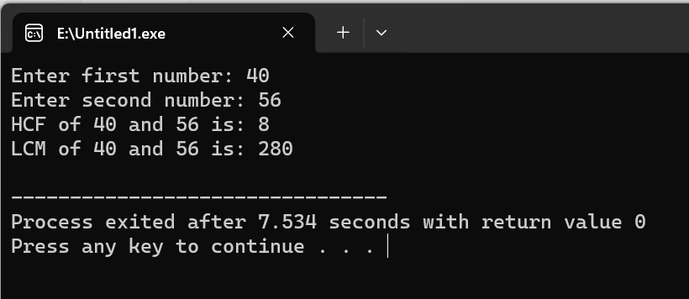

**2. Write a program in C++ to find out the sum of an Arithmetic progression series.**

#include<iostream>

using namespace std;

// Function to calculate the sum of AP series

int calculateSum(int a1, int an, int n) {

// calculate the difference of the AP series

int d = (an - a1) / (n - 1);

// calculate the sum using the formula for AP series sum

int sum = (n / 2) * (2 * a1 + (n - 1) * d);

return sum;

}

int main() {

int a1, an, n;

cout << "Enter the first term, last term, and total number of terms of the Arithmetic progression series: ";

cin >> a1 >> an >> n;

// check if the entered values are valid

if (n <= 0 || a1 > an) {

cout << "Invalid input!";

return 0;

}

int sum = calculateSum(a1, an, n);

cout << "The sum of the Arithmetic progression series is: " << sum << endl;

return 0;

}

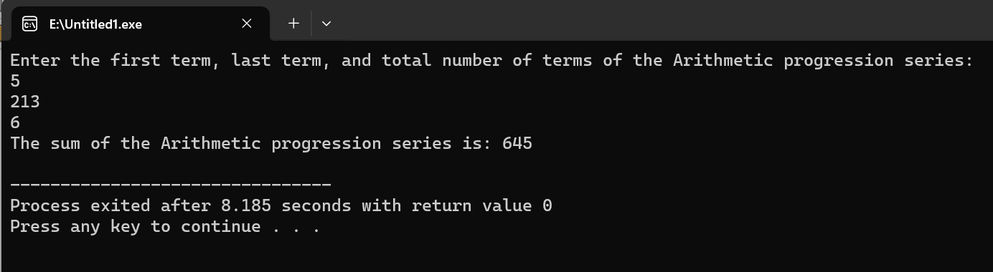

**3. Write a program in C++ to create a diamond.**

#include<iostream>

int main() {

int n = 5;

// Top triangle

for(int i=0; i<n; i++) {

for(int j=0; j<n-i; j++) {

std::cout << " ";

}

for(int j=0; j<2*i+1; j++) {

std::cout << "*";

}

std::cout << "\n";

}

// Bottom triangle

for(int i=n-2; i>=0; i--) {

for(int j=0; j<n-i; j++) {

std::cout << " ";

}

for(int j=0; j<2*i+1; j++) {

std::cout << "*";

}

std::cout << "\n";

}

return 0;

}

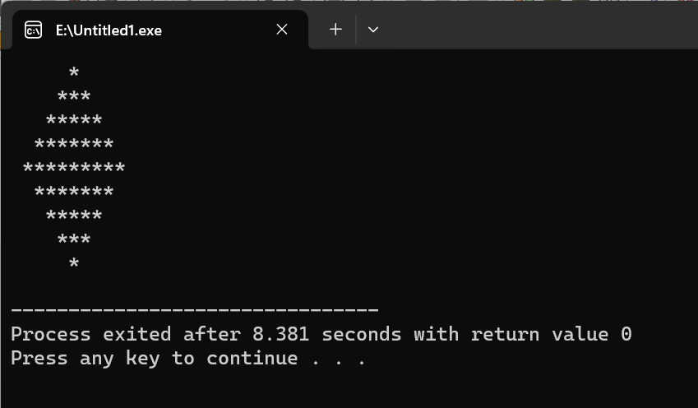

**4. Write a program in C++ to convert a decimal number to binary number.**

#include<iostream>

int decimalToBinary(int n) {

int binary = 0;

int i = 1;

while(n > 0) {

int remainder = n % 2;

n = n / 2;

binary = binary + (remainder * i);

i = i * 10;

}

return binary;

}

int main() {

int n;

std::cout << "Enter a decimal number: ";

std::cin >> n;

std::cout << "The binary representation of " << n << " is " << decimalToBinary(n) << std::endl;

return 0;

}

